Why Identity Access Management

Enable right individuals to access right resources , at the right time and for the right reason

Go to VM

Networking

Select Network Interface

Select NSG

Edit

Select None

Now take public IP of VM check in ping.eu > IP Address , 1433 It will show open

But as soon as we add or attach a NSG, it shows closed.

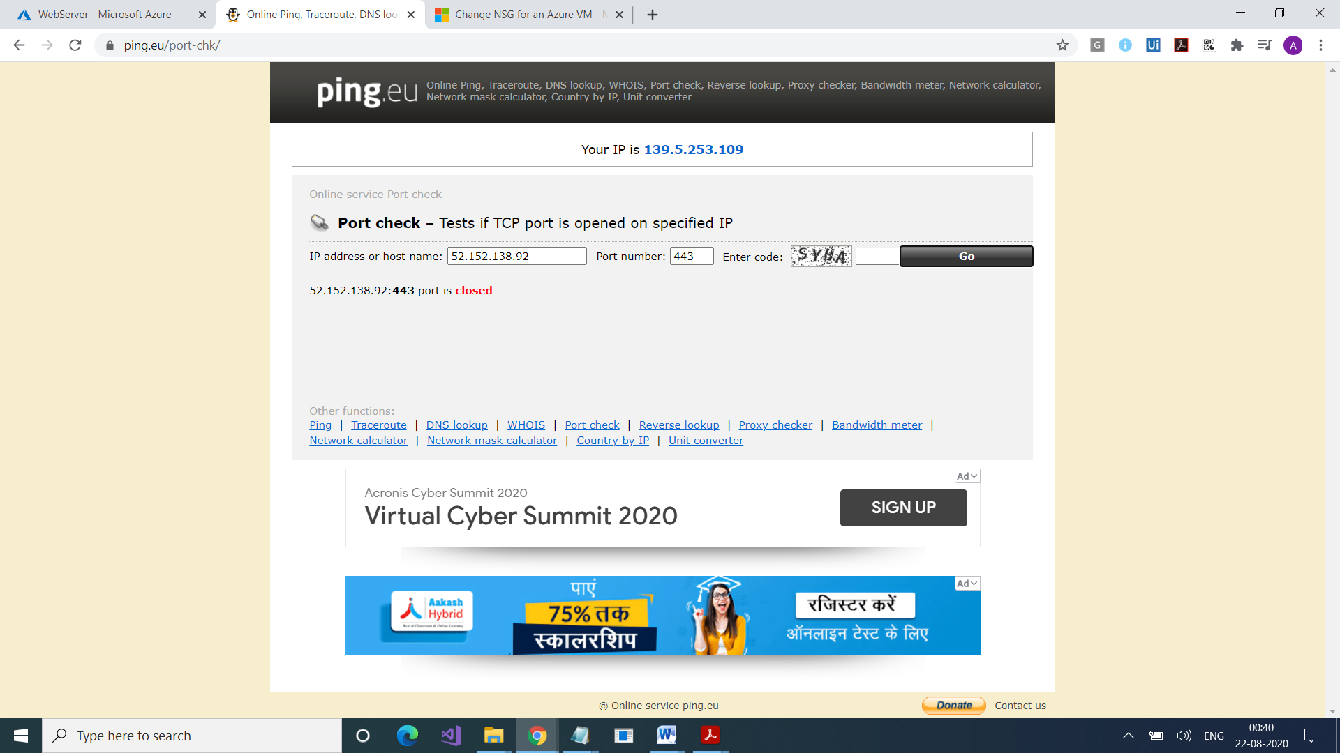

Create your nsg

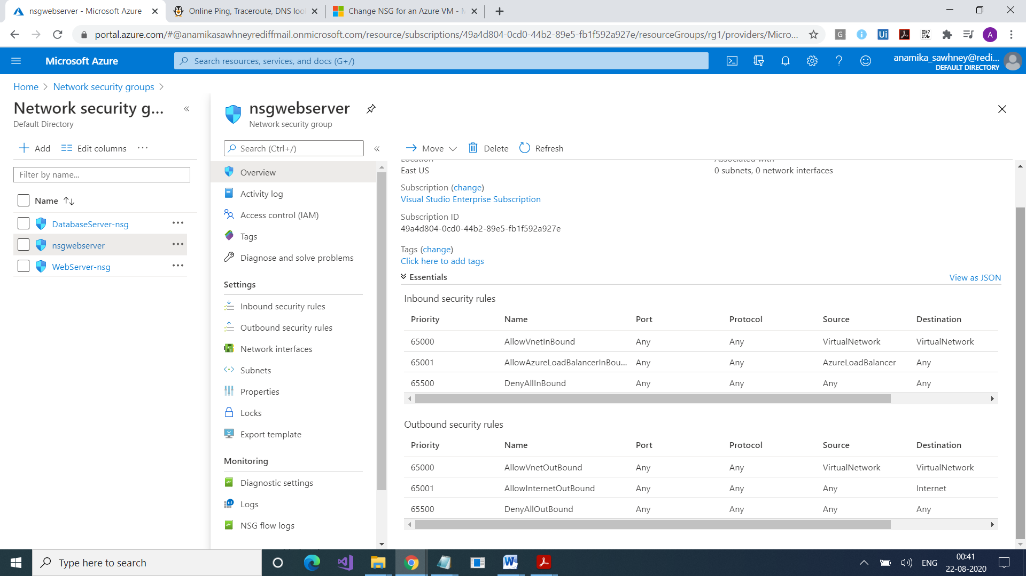

Associate it with your subnet

Go to Network Interfaces

Click on Associate

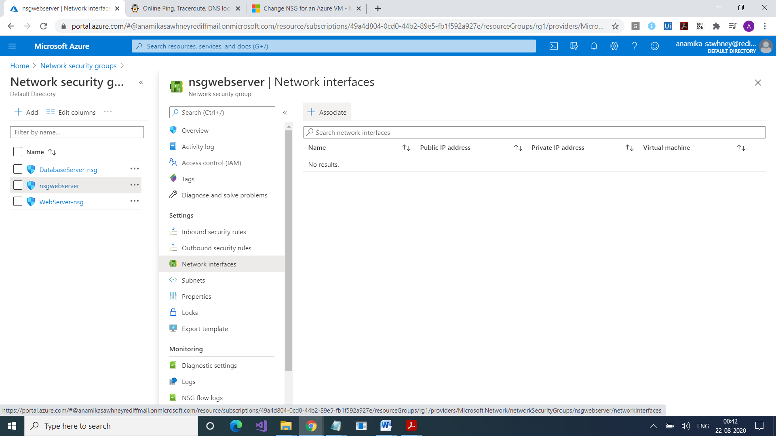

Select your NIC

Again check on ping.eu

It will show closed

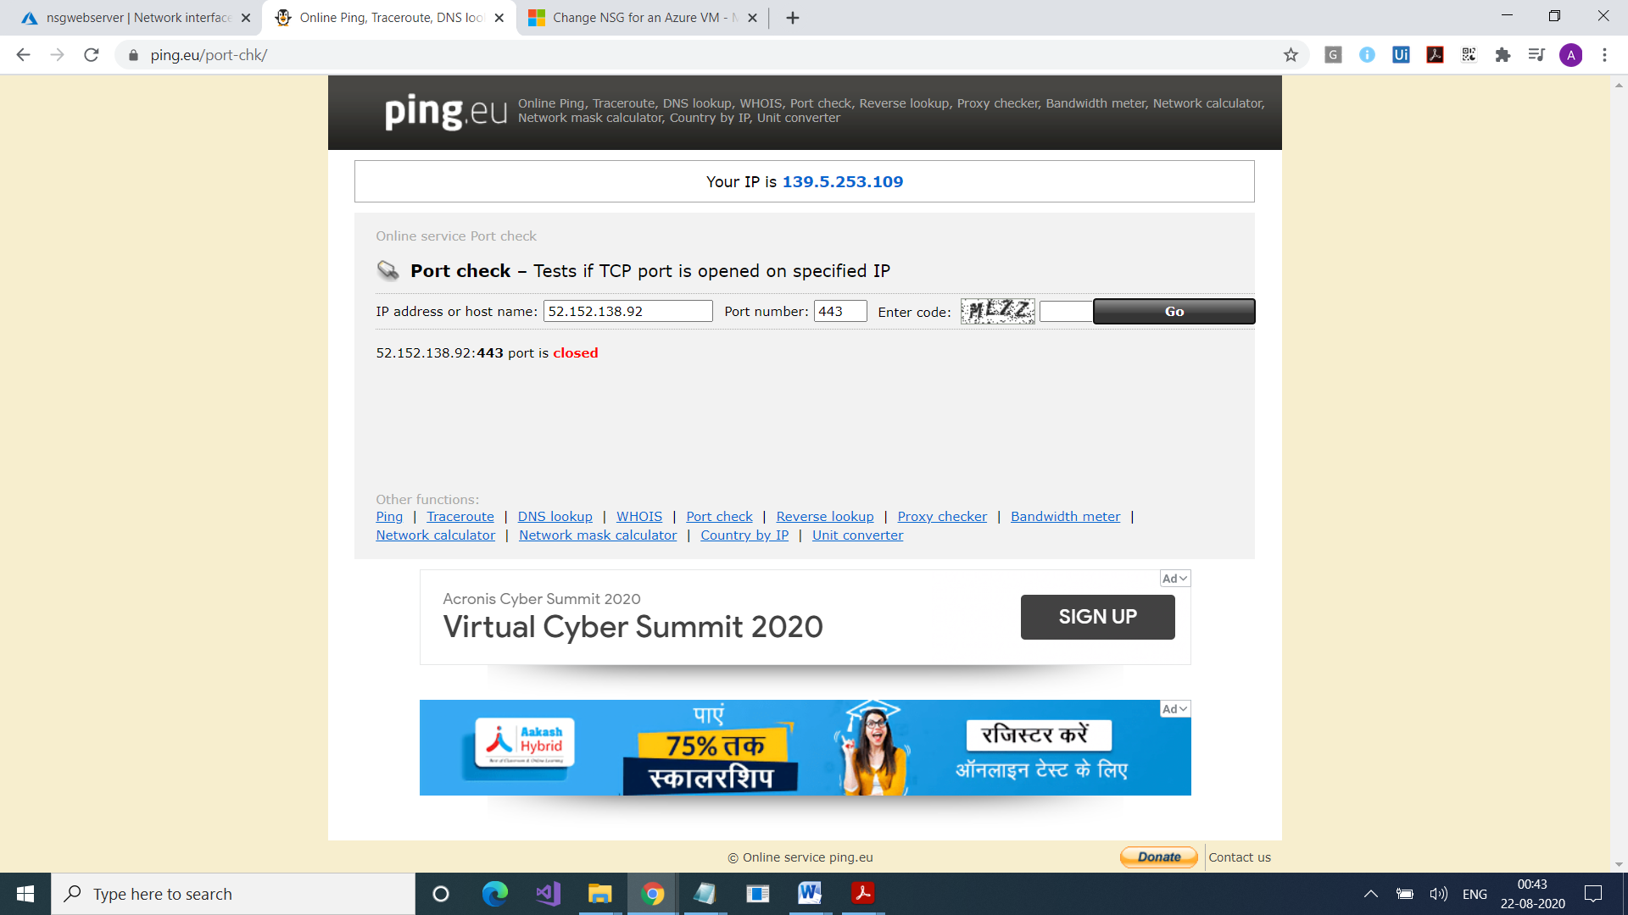

Also we can attach them at subnet level

GO to VNet

GO to subnet

Attach

